**CZRC-PA-1**

**Product:** DEAD (Asp-Glu-Ala-Asp) box polypeptide 4 **(CZRC Catalog ID:** CZRC-PA1**)**

**Abbreviation:** **Ddx4**

**Price: ¥1200/50ul**

**Isotype:** **IgG**

**Cellular Localization:** **Cytoplasm**

**Antibody type:** **Rabbit Polyclonal Antibody**

**Genecard:** **DEAD box proteins, characterized by the conserved motif Asp-Glu-Ala-Asp (DEAD), are putative RNA helicases. They are implicated in a number of cellular processes involving alteration of RNA secondary structure such as translation initiation, nuclear and mitochondrial splicing, and ribosome and spliceosome assembly. Based on their distribution patterns, some members of this family are believed to be involved in embryogenesis, spermatogenesis, and cellular growth and division. This gene encodes a DEAD box protein, which is a homolog of VASA proteins in Drosophila and several other species. The gene is specifically expressed in the germ cell lineage in both sexes and functions in germ cell development. Multiple transcript variants encoding different isoforms have been found for this gene. (From** [www.genecards.org](http://www.genecards.org)**)**

**Note:** **Please refer to the article: Ye, et al.2022**

**Species Reactivity:** **Zebrafish, Chinese rare minnow, common carp, Wuchang bream, rice field eel**

**Antibody Description:** **This antibody can specifically label the germ cell.**

**Recommended Dilutions:** **IF: 1:200-1:1000**

**Size:** **50 ul liquid**

**Phenotype:**

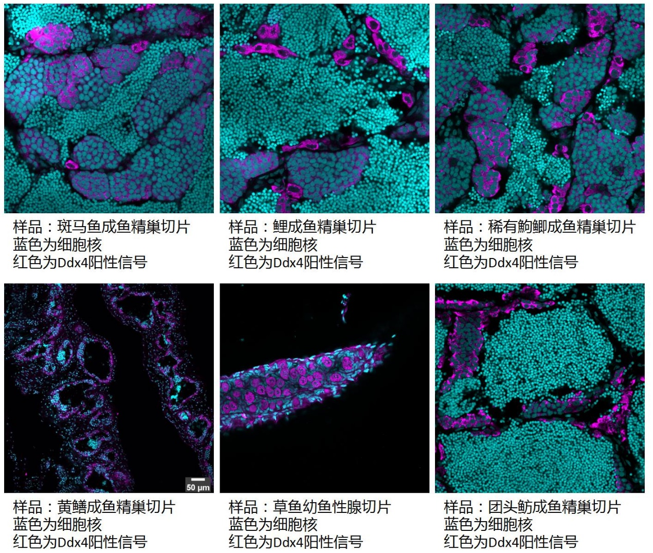

**备注：由于系统更新，订购本品系时，请订购**[**CZ500**](http://www.zfish.cn/Products/ProductDetail.aspx?CZRCID=CZ500)**，并备注本CZRC Catalog ID号。**

**特别提醒: 由于系统更新，抗体单价为¥900/50ul，故仅按这个单价*数量+运费付款即可，无需按照CZ500金额付款。**